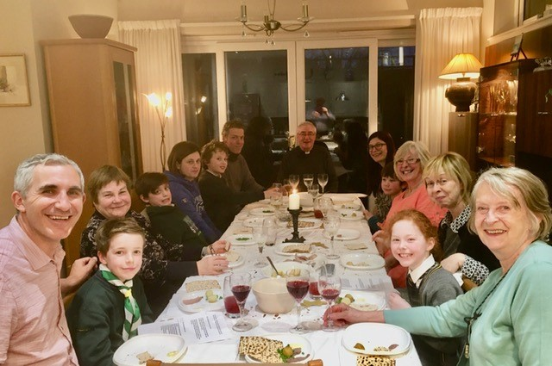

PASSOVER MEAL - St Fillan’s Newport and Our Lady Star of the Sea, Tayport, recently gathered for a Passover Meal involving five of our children – Jack, Nathaniel, Stella, Daniel and Magnus – together with Monsignor Martin Drysdale, some parents and friends. Understandably, the children’s first view of the dining table with dried Matzos, some lamb and vegetables, and not a piece of chocolate nor ice-cream to be seen, it did not entice them into believing that this was going to be the best party ever! However, once they participated in the stories from the Old Testament about the Jewish people’s great hardships in Egypt, their 40 years in the desert and their trust in God, they began to understand that this Passover Meal was special. They could now begin to link this meal with our fasting and abstinence during our 40 days in Lent and the stories from our New Testament and about all the wonderful things that Jesus did for us, and, God is still doing for us. And, yes, the sight and fulsomeness of the wine and sweet fruit juice on the table hinted at a great promise of rich feasting and the joy of the Resurrection. On Sunday May 31st, the children will celebrate their First Communion becoming active participants in our Church community, both spiritually and socially. And as grace works in their lives, they will blossom in their love for God and love of neighbour. With this next generation, our faith stories will continue to truly gather us, as Church, at other tables and other meals.

